CBN Coin:

Aim of the project is to allow the trading of secured carbon between producers and consumers allowing companies and individuals to offset production of greenhouse gasses.

How does this look:

Carbon Dioxide is predominantly sequestered in plants through the process of respiration. The most general ways of detecting respiration in plants is by determining actively growing plants. Current methods of assigning carbon storage focus on forests and trees. The aim of this project is to quantify and allocate storage of Carbon Dioxide in all growing plants. Any green area of plants is capturing and storing Carbon Dioxide from the atmosphere.

Monitoring “Green”:

Using satellite imagery to analyse enrolled area in order to assess the number of Green (actively growing) days. From this the algorithm would be applied in order allocate tonnes of Carbon Dioxide which has been stored. The Algorithm would take into account type of land practises etc in order to closely predict CO2 capture.

Each CBN coin would be 1t of Carbon Dioxide stored. By utilising blockchain technology the ledger would display exact location and time period each coin was minted through the storage of that CO2.

The Algorithm:

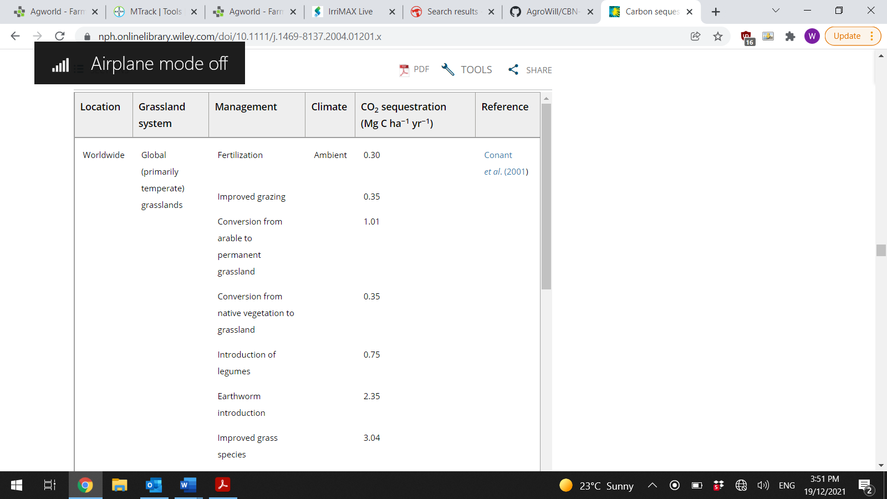

<https://nph.onlinelibrary.wiley.com/doi/10.1111/j.1469-8137.2004.01201.x>

Grassland:

Standard Grazing: 1.01 T Carbon/ha

<http://www.omafra.gov.on.ca/english/crops/facts/00-077.htm#:~:text=Plants%20during%20photosynthesis%20use%20carbon,%2Fhr%2F100%20m2>.

0.15kg C02/hr/100m2

3.6kg CO2/day/100m2

360 kg C02/ha/day

Base payment rate of 1 t of Carbon/ha per year as base rate when number of “Green Days” > 100 in 365 day period.

Option for expansion of protocols for higher payout rate if data is provided, for example soil test proof of increase in base soil carbon level over a period of time.

Ownership:

Proof will need to be provided of ownership of land, i.e proof of deed to land for individuals or proof of individuals link to company where land is owned as a part of a company.